VIETNAM INTERNATIONAL UNIVERSITY – HO CHI MINH CITY

INTERNATIONAL UNIVERSITY



WEB APPLICATION DEVELOPMENT PROJECT

Ecommerce Project

**Members of Group:**

Lê Thành Đại Dương_ITITUN14002

Vương Khắc Duy_ITITUN14010

Ninh Thế Lâm_ ITITUN14007

GitHub Link: <https://github.com/tieuduong241096/2017S2-WEB_LAB->

# Introduction

**1.1 About us**

This section will bring you the background information of our web product. The abstract description about the product that our team will design. Furthermore, the constraints which will affect our project is also included in this part.

|  |  |
| --- | --- |
| **Information** | **Details** |
| Team members | 3 members: Dương , Lâm , Duy |
| Business | Web Application Development Project: **E-Commerce Web** |
| Customer | International University – Viet Nam National University Ho Chi Minh City |
| Contact | Office: 6th floor, A Block, International University, Thu Duc, HCMC.  Email:  Tel: |

* 1. **Overview**

**Project Title** – **E-Commerce Web**

**Objective**

* To develop a web application that allows a registered customer to purchase a variety of items by a list of registered shops.
* To provide an easy to use Interface.

**Basic Requirements**

* ***Customer***
* Secured registering and managing their profiles.
* Easy navigation through pages.
* Secured Payment gateway.
* ***Shop owner***
* Secured registering and managing their profiles.
* Add, delete or modify the already posted products.
* ***Administrator***
* Authority to approve and reject requests for new items.
* Can control customers and shop owners actions.
  1. **Project Scope**
* *Scope – In*
* Websites for desktop, which is compatible with IE, Mozilla, Chrome etc.
* Purchase products available in the website.
* *Scope – Out*
* Payment Gateways to be linked through APIs.
* Not compatible for mobile users.
* *Users*
* Customers
* Shop owners
* Administrators

# Description of Features

## USE CASE 1:

**Name**: Search Product

**Description:** The list of products is showed when the user input the name of products which they want to find.

**Identifier** UC1

**Inputs**: Input desired product name

**Output**: Show all products that have the letters that user typed in

**Basic Course**

|  |  |
| --- | --- |
| ACTOR(User) | SYSTEM |
| 1.Input Product name | Display the all of products |
| 2.Click on The product | Display the photo and name of product |

**Precondition:** None

**Post condition:** None

**User Story:** As a customer, I want to search the products.

## USE CASE 2:

**Name**: Purchase History

**Description:** Show the list of purchase information of the user

**Identifier**: UC2

**Inputs**: User ID

**Output**: Information of purchase history

**Basic Course**

|  |  |
| --- | --- |
| ACTOR(User) | SYSTEM |
| 1. Login | Display login page |
| 1. Input User Name and Password |  |
| 1. Submit | * Check username and password * If true, show the purchase history * Else return to Login |

**Precondition:** Users have to log in with their own account.

**Post condition:** None.

**User story:** Customers can check the purchase history in the future.

## USE CASE 3:

**Name**: Recommend Items

**Description:** Show a several items which are in top purchase.

**Identifier** UC3

**Inputs**: none

**Output**: The list of recommend product based on mutual friends interested

**Basic Course**

|  |  |
| --- | --- |
| ACTOR(User) | SYSTEM |
| 1. Access to home page | * Show the list of recommend products. |

**Precondition:** None

**Post condition:** None

**User story:** The list of recommend products.

# Sequence Diagram

1. **Recommend product**

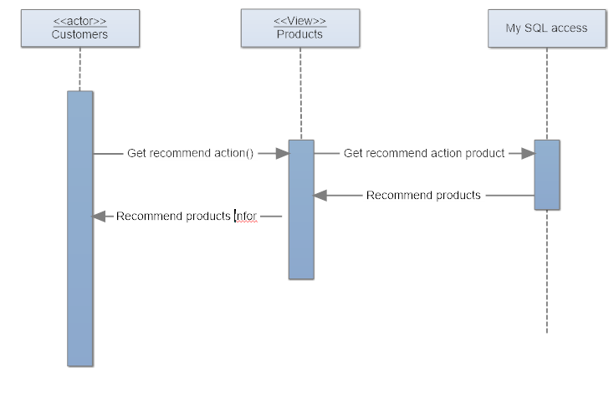

1. **Purchase History**

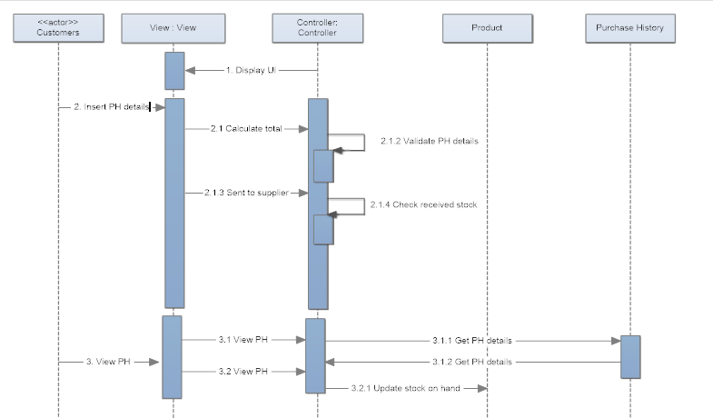

1. **Search product**

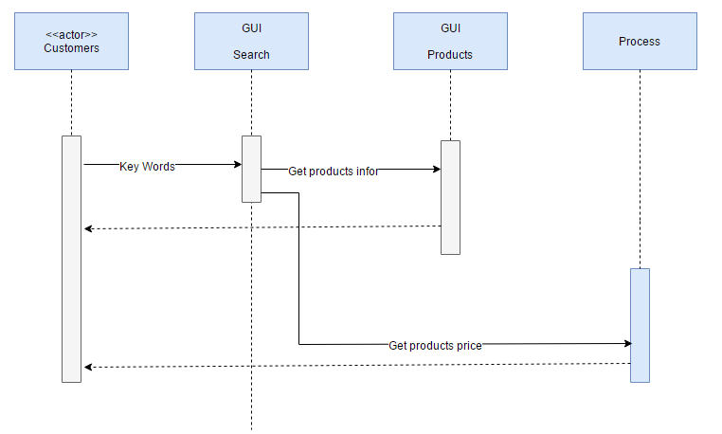

# Class Diagram

1. **Recommend product**

|  |
| --- |
| **Product** |
| ProductID: Integer  productName: String  productPrice: Double  productImage: String  productQuantity: Integer  description: String  discount: Double  count: Integer |
| getProductID(): Integer  setProductID(productID : Integer): void  getProductName(): String  setProductName( productName: String): void  getProductPrice(): Double  setProductPrice( productPrice: Double ): void  getProductImage(): String  setProductImage( productImage: String): void  getProductQuangtity(): Integer  setProductQuantity( productQuantity: Integer): void  getDescription(): String  setDescrption( description: String): void  getDiscount(): Double  setDiscount( discount: Double): void  getCount(): Integer  setCount( countNumber: Integer): void |

1. **Search Product**

|  |
| --- |
| **Product** |
| ProductID: Integer  productName: String  productPrice: Double  productImage: String  productQuantity: Integer  description: String  discount: Double  count: Integer |
| getProductID(): Integer  setProductID(productID : Integer): void  getProductName(): String  setProductName( productName: String): void  getProductPrice(): Double  setProductPrice( productPrice: Double ): void  getProductImage(): String  setProductImage( productImage: String): void  getProductQuangtity(): Integer  setProductQuantity( productQuantity: Integer): void  getDescription(): String  setDescrption( description: String): void  getDiscount(): Double  setDiscount( discount: Double): void  getCount(): Integer  setCount( countNumber: Integer ): void |

1. **Purchase History**

|  |
| --- |
| **ReceiptDetailProduct** |
| bookDate: Timestamp  payMode: String  shipAddress: String  quantity: Integer  price: Double  size: Double  productName: String |
| getBookDate(): Timestamp  setBookDate( bookDate: Timestamp ): void  getPayMode(): String  setPayMode( payMode: String ): void  getShipAddress(): String  setShipAddress( shipAddress: String ): void  getQuantity(): Integer  setQuantity( quantity: Integer ): void  getPrice( ) : Double  setPrice( price: Double ) : void  getSize(): Double  setSize( size: Double) : void  getProductName(): String  setProductName( productName: String ): void |

5. Database Diagram

Entity Description

**PRODUCT**

|  |  |  |  |  |  |  |  |
| --- | --- | --- | --- | --- | --- | --- | --- |
| Field name | Type (size) | Identity | NULL | PK | FK | References | Description |
| ProductID | int | yes | no | PK |  |  | Product identity number |
| ProductName | varchar(255) |  | no |  |  |  | Product Name |
| ProductPrice | double |  | no |  |  |  | Product’s Price |
| ProductImage | varchar(255) |  | no |  |  |  | Product’sImage |
| ProductQuantity | int |  | no |  |  |  | Product’s Quantity |
| Description | varchar(255) |  |  |  |  |  | Product’s Description |
| Discount | double |  |  |  |  |  | Product’s Discount |

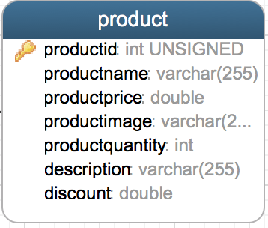

**PURCHASE HISTORY**

|  |  |  |  |  |  |  |  |
| --- | --- | --- | --- | --- | --- | --- | --- |
| Field name | Type (size) | Identity | NULL | PK | FK | References | Description |
| ReceiptID | int | yes | no | PK |  |  | Receipt identity number |
| BookDate | datetime |  | no |  |  |  | User’s purchase date |
| Status | varchar |  | no |  |  |  | Status of receipt |
| ShipAddress | varchar |  | no |  |  |  | Address to arrive |
| PayMode | varchar |  | no |  |  |  | Pay mode of receipt |
| ShipDate | datetime |  | no |  |  |  | Ship Date of receipt |
| ProductID | int |  | no |  | FK | Product(ProductID) | One receipt detail has many product |

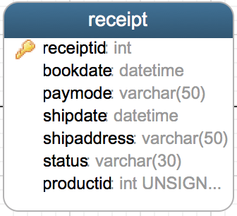

**USER**

|  |  |  |  |  |  |  |  |
| --- | --- | --- | --- | --- | --- | --- | --- |
| Field name | Type (size) | Identity | NULL | PK | FK | References | Description |
| UserID | int | yes | no | PK |  |  | User identity number |
| UserName | varchar(30) |  | no |  |  |  | User name to login |
| Password | varchar(30) |  | no |  |  |  | User’s password to login |
| UserAge | int |  | no |  |  |  | User age |
| UserGender | bit |  | no |  |  |  | bit 1: Male; bit 0: Female |
| UserAddress | varchar(255) |  | no |  |  |  | User’s Address |
| Email | varchar(255) |  | no |  |  |  | User’s Email |
| FullName | varchar(255) |  | no |  |  |  | User’s FullName |
| Phone | varchar(15) |  | no |  |  |  | User’s Phone |
| ReceiptID | int |  | no |  | FK | Receipt(receipteid) | One user have one or more receipt |

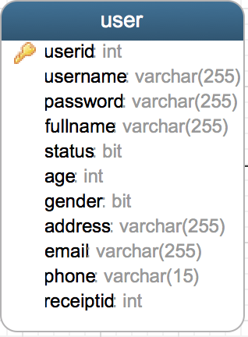

Tables Design

